Pier Cottage

i. General

Pier Cottage is a handsome very square and compact structure of two storeys and three bays underneath a double pitched slated roof defined by double chimneys at either apex and gableheads. The chimneys are defined by skews and simple squared skewputs. The building is slated, but the slating appears to be relatively recent in date. The external walls are harled and whitewashed in cream. Its principal frontage faces to Loch Fyne to the west. This elevation is handsome and regularly arranged, with pairs of windows, one at each level, on either side of a central porch and above the porch roof there is a further blocked window of smaller size.

The building can possibly be identified on the First Edition OS Map (6 inch) surveyed in 1870. It is now occupied by Elsie and Dom Adams.

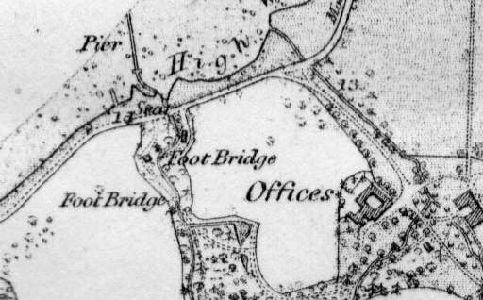
Figure 5: 6 inch Ordnance Survey Map, First Edition 1870. National Map Library of Scotland.

The existing entrance and driveway skirts the house on its north side and leads to a gravel yard area behind the house to the east. Bounding the south side of the yard area is a small range of sheds. This has three entrances facing into the yard in its north wall. Each of these entrances contains a plank and batten constructed door, the vertical planks detailed at the tongue and groove joint with a bead. Architraves around have rolls at inner angles and ogee mouldings on the outer.

The sheds on the south side of the court at the back are built of lime bonded rubble construction. This is visible internally with some evidence for brickwork forming up at the entrances. Externally it is harled with cement and whitewashed. The eastern compartment preserves some timber linings bedded within the wall and in the east wall in particular, there is a suggestion that the mortar was smeared up against lining boards within. It is not clear what the significance of this may be. The western compartment appears to have been the early wash house. This has a concrete floor with channels in it for drainage. In the south-west corner in the upper wall, there are the remains of a flue rising up to a small chimney. The impressions of this can be seen lower down and its possible there had been a pot boiler at that point. In the centre of the west wall there is an early window opening. It appears that the northwest corner of this interior was subdivided further, by brick partitions perhaps, the impressions of which can be seen in the plasterwork to the north and west. Perhaps this had been a small privy. This had a separate entrance now partly blocked in the north wall.

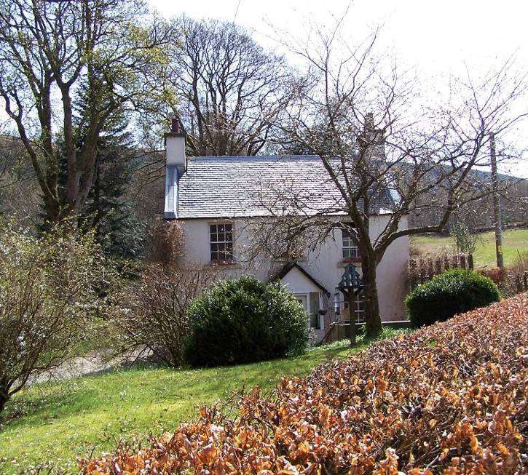 |  | 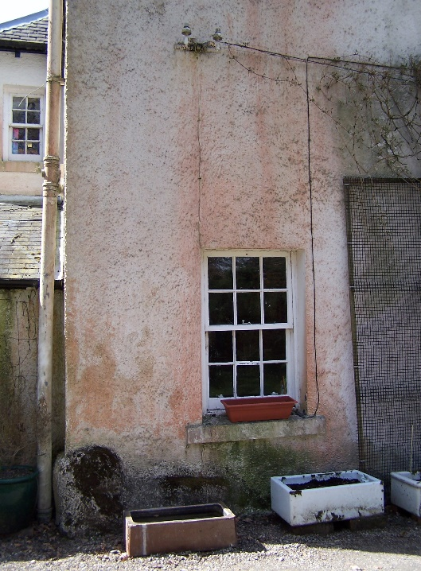
Plate 46: W elevation from road. |  | Plate 47: Detail of N elevation with single window and rubble footing course.
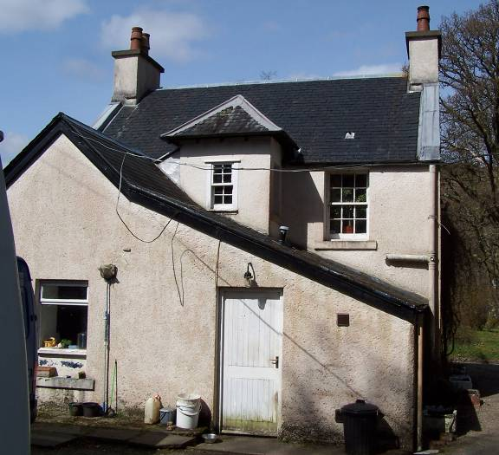 | 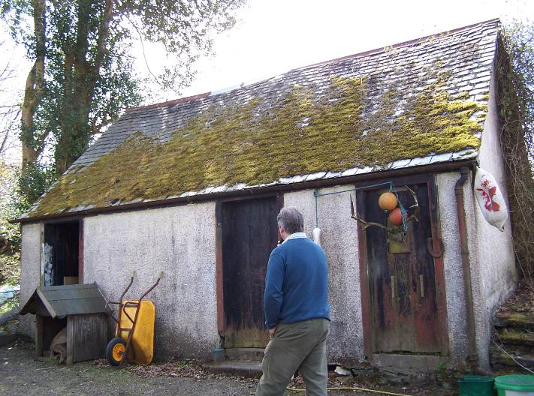
Plate 48: Rear elevation to E. | Plate 49: N elevation of small range of sheds.

The centre of the east wall at ground floor level there is a fixed window. This of two by four panes, horizontally set with a deep fillet-and-ovolo profile. Above this is an entrance to a small loft area. This containing a plank and batten door. A small single loft chamber occupying slightly more than half of the upper level. This has a broad dormer within the roof facing south but does not appear to be of particular antiquity. It contains three window panels divided by wooden mullions. Each panel contains two by four squared panes. The upper part of the central one clearly opened. The outer ones appear to be hinged on the outer jambs. The sides of the dormer are match boarded.
The porch is walled with a door in the centre of the west side. Above it is glazed and defined by vertical timber piers that have chamfers round the corners. The roof above is slated with shaped fishtail slates. Every third coarse being square ended. The roof is double pitched and detailed with a moulded fascia and a wooden finial at the apex. The guttering at either end is detailed with spouts formed out of lead almost in the shape of bird heads. The sills of the windows project out. If these are stone then they seem to have been rendered over. At the wall foot of the cottage there is a projecting footing coarse formed of small boulders. On either side of the porch there are small cobble edged borders.

The north gable wall is without feature other than a single window towards the east end at ground floor level. This arrangement is similar to that of the south gable, again with a single window in the corresponding position. In the centre of the rear wall to the east there is a small projecting stair tower, externally this is now only visible above the roofs of further additional ranges. The inspection of the interior revealed that this stair does not contain the present stair.

Running eastwards from the southern part of the east façade is a double-pitched single-storied range beneath a slated roof. This is detailed with a wooden fascia to the east. On its northern pitch there exists what may be yet a further extension. This has a single pitched roof that joins up to the main roof of the rear range in a cat-slide arrangement. The combined rear range which corresponds to the width of the back of the house is accessed externally from a single entrance further north in the east wall.

At first floor level there has clearly been some arrangement although all of the windows that are still in position appear to be original except the first floor window in the south gable which is of different moulding profile and fresher cut suggesting this is a secondary insertion or replacement. All the other windows have a narrow Victorian gothic glazing bar profile. Each window is sash-and-case and six-over-six in arrangement.

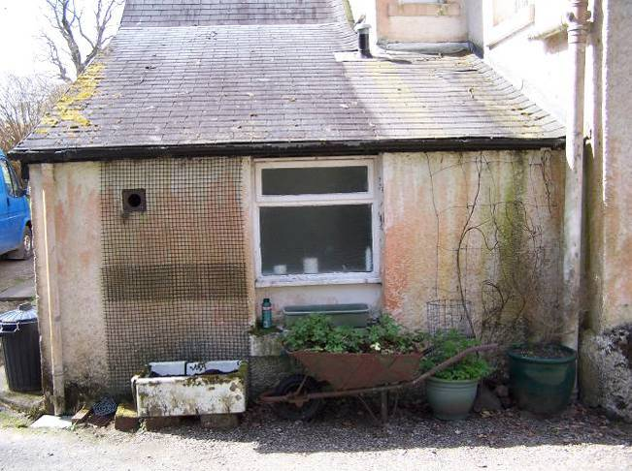 | 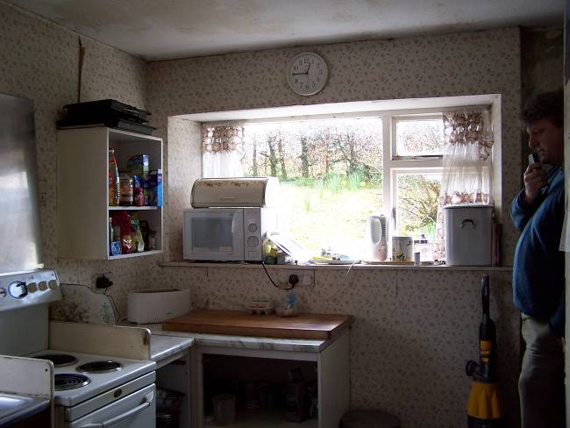
Plate 50: N elevation of E extension,  bathroom window. | Plate 51: Large kitchen window facing S.

iii. Interior – Ground floor

As the entrance through the porch in the W elevation is closed off, the main entrance into the house is now at the back, through the eastern extension. The principal part of this rear extension which is the southern part, now contains a kitchen with kitchen units that appears to be of 1970s or early 1980s date. There is a broad south facing window that is clearly a secondary insertion in the centre of the east wall. There is also a further window to the E, its narrowness suggesting this might be an early window though the fenestration within is modern.

The northern part of the extension contains a short passage from the external door and this leads into the south side to the kitchen. On the north side is a small bathroom with bath and WC, all tiled out and relatively modern internally. The kitchen extension and all parts of the rear are lined out with plasterboard. There is a concrete floor throughout.

At the northern end of the west wall of the kitchen there is a passage that leads through to the principal ground floor part of the main house. The latter is now formed into one single interior space; however it is evident that this had been subdivided formerly. Patchings of the floorboards either visible, or almost visible beneath the carpets, suggest there had been a small entrance vestibule within the porch, with an entrance on either side to north and south. Evidence to the south is readily visible as a patching in the floorboards. There seems to have also been an east-west partition wall. This is slightly offset to the south, running to the south jamb of the entrance into the rear extensions. This again is apparent as a patch on the floor beneath the carpet.

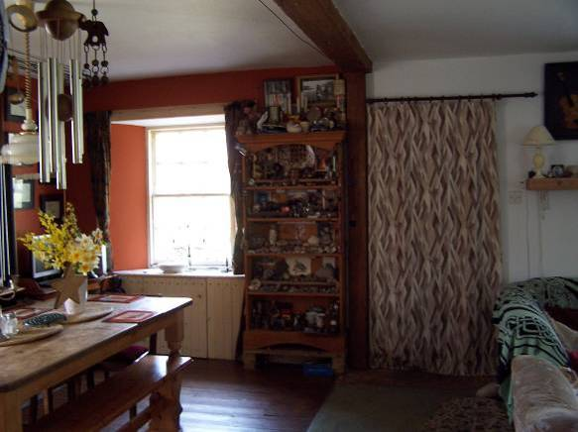 | 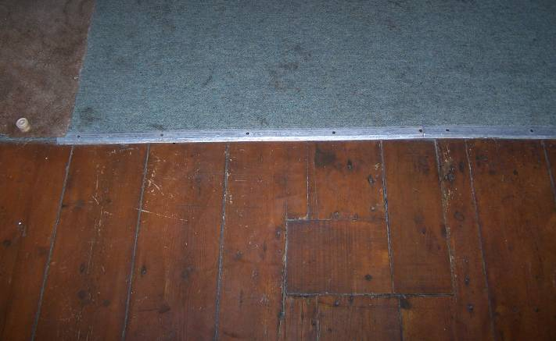
Plate 52: View into front room of original cottage, previously split into two rooms. Curtain covers original porch entrance. | Plate 53: Detail of floor with possible evidence for removed partition wall in original vestibule area.

There may have been a second internal parallel crosswall running to the northern jamb of the original entrance into the rear. The usual arrangement of many of these Cairndow buildings is to have a straight flight of stairs rising up within the entrance vestibule directly opposite to the upper level. It is not clear if this had been the original arrangement here, but it is certainly a possibility.

The existing stair arrangement is somewhat unusual. It rises up from within the kitchen range at the back, rises westwards and then turns clockwise to the north, running to a straight flight up to the landing leading to the upper level. All of the woodwork details, skirtings, window surrounds etc, correspond to the early moulding details that survive at first floor level. There are two small windows at the head of the stair, one facing north, one facing east. These with the gothic moulded profile seen elsewhere.

The kitchen outshot / extension at rear seems likely to be early as well, although it is now heavily lined out with plasterboard that obscures earlier features behind. A window towards the bottom of the stair in the south wall is early and original, four over four sash and case like the ones at the head of the stair. These with small panes. There is an understair area which formally had been shelved, one or two still existing. This likely to have been a small larder area. The doorway within is now modern.

The ground floor interior within the main cottage part, whatever its pre-existing arrangement might have been, has now been formed into a single space. This is detailed with two windows symmetrically arranged on the west frontage and one each in the north and south gables. These are offset to the east. With the exception of the south-east window, all of these are detailed with narrow gothic profiles, the one to the south-east has a fillet-and-ovolo profile. The freshness of its paintwork etc suggests this may be a secondary replacement. There is a fireplace opening in the north wall offset to the west. This has simply been opened out and any pre-existing surround has been removed. The odd stone might survive but it is beneath a raised hearth area formed of stone slabs. There is a wood burning stove within the old opening. In the south gable wall offset to the west there is a hearth stone for a second fireplace. This has previously heated the southern room; the hearthstone still visible at floor level. There is no surviving evidence to suggest that these ground floor interiors had ever been corniced. The existing ceiling appears to be plain plaster. There are simple architraves, detailed as elsewhere, around the various window openings. The ground floor is wood-floored throughout in the principal part.

iv. Interior – First floor

The first floor is accessed by the existing stair from the kitchen, which rises to a landing in the centre of the east wall. This now leads to a small vestibule area. Halfway up the straight flight on the east side there is a small hatch into the roof space above the kitchen area. The stairwell is plastered internally and where later paper is peeling off, there is evidence of paintwork underneath. This one or two coats of turquoise, possibly the earlier one is a distemper and original.
On the north side of the landing an entrance leads into a small bathroom and on the west side of the landing further north is another little entrance leading to a bedroom which occupies the north-west part of the upper level. The partitions dividing these two rooms appear to be secondary. Certainly the entrance surrounds within are relatively modern, the architraves with simple rounded angles and hardboard doors within. A further bedroom is accessed in the S.

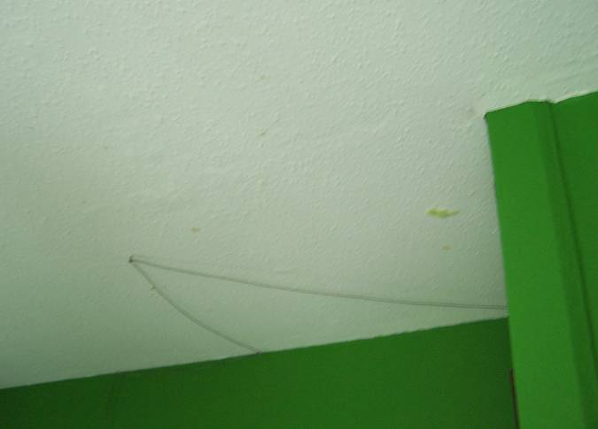 | 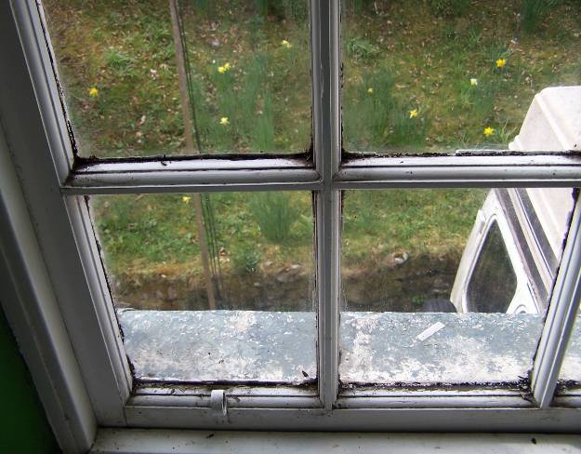
Plate 54: NE corner of ceiling in first floor bedroom in S; possible evidence for removed partitioning. | Plate 55: Window in S bedroom on first floor in S elevation, detail of fillet-and-ovolo profile.

All of the upper level seems to have undergone some considerable rearrangement. However, the entrance on the south side of the vestibule has an early architrave with a roll within, an ogee without and this leads into the large rooms that occupies much of the south end of the first floor level. There is some suggestion on the ceiling that this room had been smaller and perhaps the existing north wall of the room is a modification. This room has windows to the west and the south. These are detailed with architraves, similar to those at the entrances. There seems likely to have been a fireplace in the centre of the south wall, however, this is wholly obscured and built over.

The bedroom to the northwest has few features other than the window in the west frontage. There had likely been a fireplace in the centre of the north gable wall, however, this is now removed and lined over. At the northeast corner of the bedroom there is a small linen press with doors on the west side. There seems likely to have been a small room in the centre of the west side of the building as there is a small window above the porch visible externally, now blocked.

